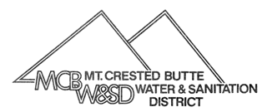
Mt. Crested Butte Water & Sanitation District
PO Box 5740
Mt. Crested Butte, CO 81225-5740
(970) 349-7575 Fax: (970) 349-0412
info@mcbwsd.com

PROPERTY MANAGER INFORMATION

To: Mt. Crested Butte Water & Sanitation District: Date: __________________________
Please update the caretaker or property manager information on the following account(s).

Effective Date: _____________________________________

Account Number(s): _____________________________________

Street Address(es): _________________________________________________________

Care Taker or Property Manager Information:

Name(s): ________________________________________ Phone: _____________________

Email: ________________________________________________

Address: __________________________________________________________________

PO Box(es): __________________________________________________________________

City: ___________________________ State: _____________ Zip: ______________________

Property Owner Information:

Name(s): ________________________________________ Phone: _____________________

Email: ________________________________________________

Address: __________________________________________________________________

PO Box(es): __________________________________________________________________

City: ___________________________ State: _____________ Zip: ______________________

Property Owner’s Signature: ___________________________________________

DISTRICT NOTIFICATION IS REQUIRED WHEN A PROPERTY IS SOLD AND A CORRECT BILLING ADDRESS
For Office Use Only: Date: __________By: _____
Direct Pay: ____No____Yes

