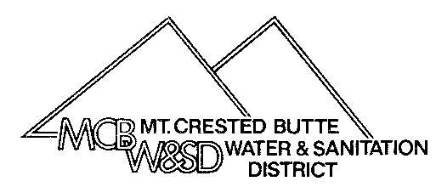
Mt. Crested Butte Water & Sanitation District
PO Box 5740
Mt. Crested Butte, CO 81225-5740
(970) 349-7575 Fax: (970) 349-0412
info@mcbwsd.com

CHANGE OF ADDRESS AND/OR OWNERSHIP

To: Mt. Crested Butte Water & Sanitation District: Date: ________________________
Please change the billing address and/or ownership information on the following account(s).

Effective Date: _____________________________________

Account Number(s): _________________________________________________

Old Address:_________________________________________________

City:____________________________ State:____________ Zip:______________

*******************************************************************************************************
New Address:_________________________________________________

City:___________________________ State:_____________ Zip:______________

New Phone number: ________________________ Email: __________________________

Owner Information:

Old Owner Name(s): _________________________________________________________

New Owner Name(s): _________________________________________________________

Is the new address listed above for the new owner listed here? Yes____ No_____

Reason for ownership transfer: ____________________________________________

Signature: _________________________________

*NOTE: All ownership transfers will require a legal document showing sale or transfer.

For Office Use Only

Date: __________By: _____
Direct Pay: ____No____Yes

